Job Description / Specification
Job Title: | Product and Category Manager
Reporting to: | Head of Product and Market Innovation
Department: | Marketing & Product
Organisational Structure
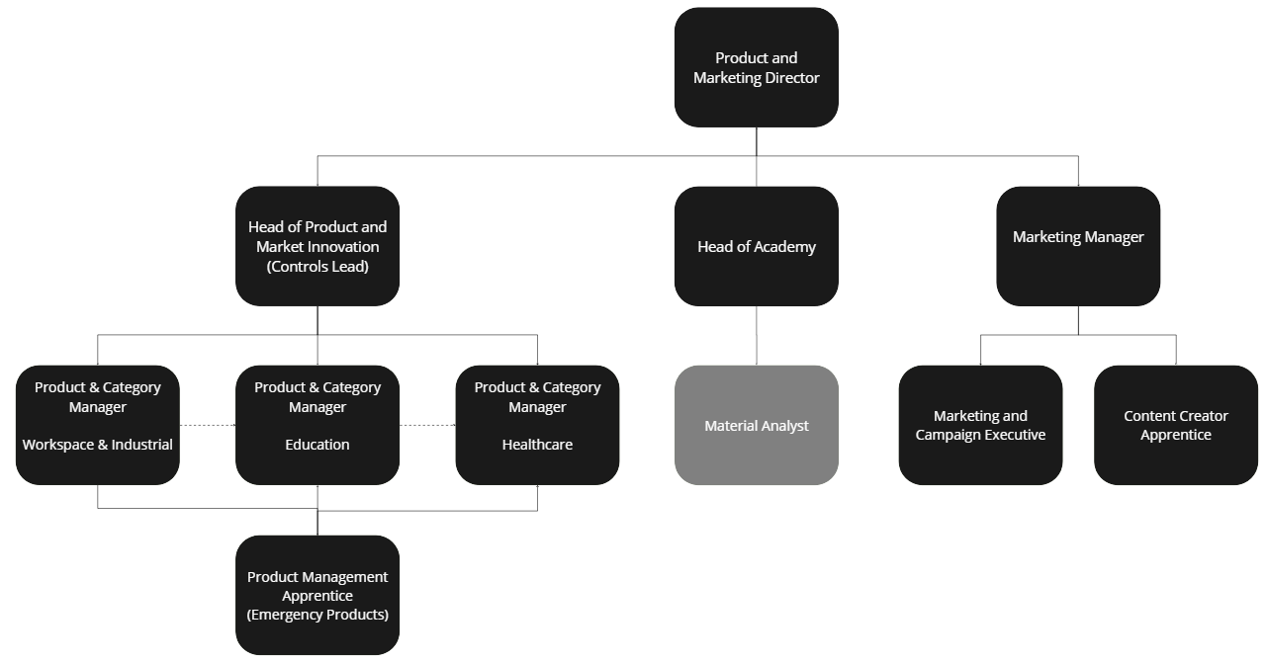

Purpose of the Position
Drive the success of our lighting products and services by developing and executing strategic plans that meet customer needs and capitalise on market opportunities.

Key Responsibilities
Product Portfolio Management:
Manage the lifecycle of assigned lighting products and categories, from concept to end-of-life, ensuring alignment with business objectives, market trends, and customer demands.
Conduct market research and analysis to identify product gaps, opportunities for innovation, and competitive threats within assigned categories.
Strategic Planning and Road mapping:
Develop and deliver the 2-5 years category strategy and product roadmaps, aligning to the strategic plan for the business/group, to drive revenue and profit growth.
Collaborate with cross-functional teams, including product development, marketing, sales, and operations, to execute strategic initiatives and bring products to market effectively.
Product Development and Launch:
Lead the product development process, from concept ideation and requirements definition to product design, testing, and commercialisation, ensuring products meet quality standards, regulatory requirements, and customer expectations.
Manage the launch of new products and product enhancements, coordinating with marketing and sales teams to develop go-to-market strategies, promotional campaigns, and sales enablement materials.
Market Analysis and Insights:
Monitor market trends, competitive landscape, and customer feedback within assigned categories, providing insights and recommendations to inform product strategy, pricing decisions, and marketing initiatives.
Analyse sales performance, market share, and profitability metrics for assigned products and categories, identifying areas for growth and optimization.
Customer Relationship Management:
Build and maintain strong relationships with key customers, partners, and stakeholders in the lighting industry, understanding their needs, preferences, and pain points to drive product innovation and enhance customer satisfaction.
Performance Measurement and Reporting:
Define key performance indicators (KPIs) and metrics to track the performance of assigned products and categories, providing regular reports and updates to senior management on product performance, market trends, and strategic initiatives.

Responsible for your continuous personal and professional development enabling effective delivery within your role and career.

Specific Skill Requirements
 | Essential | Desirable
Education  / Technical Skills | - Solid understanding of product management principles, methodologies, and best practices, gained through relevant education or experience within the lighting industry or related sectors.  - Proficiency in market research and analysis techniques, including qualitative and quantitative methods, data interpretation, and trend forecasting.  - Advanced strategic planning skills, with the ability to develop and execute comprehensive product strategies and roadmaps, aligning business objectives with market opportunities and customer needs.  - Strong interpersonal and communication skills, with the ability to collaborate effectively with cross-functional teams, including product development, marketing, sales, and operations,  - Sound financial analysis skills, including budgeting, forecasting, and cost-benefit analysis, and sales analysis to enable effective decision-making and resource allocation.  - Proven ability to build and maintain strong relationships with customers, partners, and stakeholders, leveraging excellent communication, negotiation, and problem-solving skills. | - Specific Lighting industry knowledge and experience  - Specific knowledge of Dali, wirepass, RF mesh technologies and Cloud API’s.  - Knowledge and experience in aligned industries within manufacturing or built environment.
Behaviors | Curious Creator  - Innovate Fearlessly: Fail fast and learn from failure.  - Embrace Curiosity: Foster an open-minded culture of inquiry, challenging assumptions, and exploring possibilities.  - Own the Strategy: Develop the strategy, act decisively, while always considering how it contributes to our shared vision.  Committed Together  - Listen Actively: Prioritise understanding, approaching every interaction with genuine interest, actively seeking to understand and connect.  - Customer Connection: Put our customers’ problems at the heart of everything we do, striving to unlock solutions that are truly valuable.  - Share Freely: Foster a culture of open communication and collaborative sharing or knowledge.  - Inspire and Collaborate: Motivate and collaborate with others to achieve shared goals, celebrating collective success and fostering cohesion within the team.  Aim Higher  - Unwavering Integrity: We conduct ourselves with unwavering honesty, consistency, and persistence, ensuring trust and accountability in all our endeavors.  - Expertly Informed: Be the industry experts, acquire and share knowledge confidently, grounding decisions in expertise and factual understanding.  - Pursue Growth: Foster a mindset of continual learning, embracing challenges, and seeking opportunities for personal, professional and business development.

Written By: | Michael Govier | Date: May 2024

